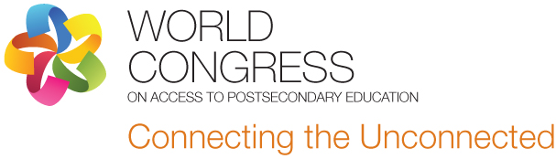

On behalf of the European Access Network, we are writing to invite representatives from your country to the World Congress on Access to Post-Secondary Education: Connecting the Unconnected in Montreal, Canada from Oct. 7 – 10, 2013.

Ensuring strong economic growth is an issue in both developed and developing countries. The World Congress is focused on the economic and social impact that can be made when various levels of government improve the rates of participation and success of people who have traditionally been under-represented in post-secondary education.

Research links higher levels of education with improved social and economic wellbeing for both individuals and communities. Education supports the economic growth and development of nations, for increased knowledge and skills enable wealth-creation. We feel that participation gaps represent lost opportunities: a waste of talent and potential.

At the World Congress, participants will consider initiatives to widen access to higher education that involve co-operation among multiple partners in cities and regions; projects that provide enhanced provision for targeted groups (e.g. low-income, minorities, disabled); and initiatives that seek to stimulate economic development through providing access opportunities for those already in employment.

The Congress is inviting international representatives to bring new ideas, strategies and approaches to tackle challenges of post-secondary access, and thereby create opportunities for people from all regions and backgrounds to contribute to the wellbeing of their communities and countries. With your participation, we can link efforts, resources and ideas across regional boundaries.

If you would like to share initiatives that your district, region or country has developed to widen access to higher education, please see the attached call for proposals.

Our website is located at www.eanworldcongress.org. Registration for the congress will open in April. Special rates have been arranged at local hotels for our international delegates.

