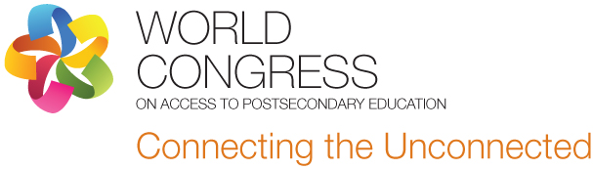


World Congress Series on Access to Post-Secondary Education
“Connecting the Unconnected”

Call for Proposals:
Linking economic and social development to post-secondary education in urban areas

--------------------------------------------------------------------------------
We invite you to submit a proposal for a presentation or activity within this strand that will provide a framework for discussions and planning during the congress. We are seeking inspiring and thought-provoking presenters to discuss strategies and best practices, and/or innovative approaches, initiatives, and programs that have been implemented to increase access to post-secondary education in urban areas.

As this is a congress, not a conference, all proposed activities should include interactive elements. We will consider activities that relate to initiatives that widen access to higher education that involve co-operation among multiple partners in cities and regions; projects that are directly targeted to particular imperatives of city and regional authorities to provide enhanced provision for targeted groups (e.g. low-income, minorities, disabled and the geographically isolated); and initiatives that seek to stimulate economic development through providing access opportunities for those already in employment.
Initiatives, programs and strategies might relate to, but are not limited to:

- Institutional policy change initiatives for broadening access to post-secondary education
- Collaborative and partnerships strategies for access and delivery in urban areas
- Innovative and alternative program delivery models within urban areas
- Non-traditional pathways in accessing post-secondary education
- Urban education centres focused on broadening access, i.e. city-wide or city-led strategies
- Technological innovation as an approach to broadening post-secondary access in cities

All proposals must:

- Provide a brief background of your institution and its commitment to access to post-secondary education.

- Provide a description of the initiative, program or strategy and how it is operating at a systemic level.

- Describe the benefits the initiative, program or strategy will bring to Congress attendees, including how the initiative, program or strategy will inform others' work and what aspects might be adapted by session participants.

- Describe the success criteria and outcomes for the initiative, program or strategy.

- Describe the impact the initiative, program or strategy has had on students, the community, and the institution on improving/increasing access.

- Describe how the initiative, program or strategy is evaluated.

- Describe any challenges and/or risks that were encountered.

- Demonstrate how your delivery format will be collaborative, innovative and interactive and employ the use of active learning strategies (i.e. active discussion, group activities, the use of multi-media, sharing opportunities, case-studies, and question & answer period)

Delivery:

- Each session is 90 minutes. There is a possibility of having 2 presentations in the same session, with 45 minutes allotted to each presentation. Please indicate if you would prefer the entire 90 minutes, or 45 minutes.
- Presentations should be innovative and interactive
  - Explore ways to move beyond the traditional lecture style to involve participants in active learning and promote interaction with presentation.
- Where possible, sessions should include youth voices and/or participants from the program/project/initiative.

Criteria for Submission Review and Selection:

Clarity and coherence of submission
Clarity of session relevance and outcomes
Relevance to the Congress theme
Relevance and usefulness to the intended audience
Presentation approach and level of participant engagement in the session
Contribution to scholarship and/or innovative practice in education.

Please email your submission to k.bedeau@georgebrown.ca, cc: sueferguson52@gmail.com

Due Date for submissions: May 15, 2013

