The geographical and temporal displacement of young people’s knowledge and agency: impacts for food security and environmental change.
Environmental changes associated with climate change will impact on the lives of present and future generations of people in Tanzania, of whom the majority rely on subsistence agriculture, pastoralism and use of natural resources to sustain their livelihoods (NBS Tanzania 2006).
Whilst there is evidence that those reliant on natural resources are capable of adapting to environmental changes in African contexts (Briggs et al 2007; Moyo 2009; Sharp et al 2003) there have also been significant efforts by the international community, the Tanzanian government, and Non-Governmental Organisations (NGOs) to mitigate for environmental changes by providing environmental education (NEMC Tanzania 2004; Hoza 2009; Mbuta 2009). State curricula in Tanzania, and various NGO projects, have sought to provide young people with knowledge of climate change and associated environmental issues (forest clearing, fish stock depletion, biodiversity). Many of these young people, particularly those in rural Tanzania, are likely to continue to rely on local natural resources in both their young and adult lives and therefore environmental changes, and the education they receive at school, may have a significant impact on their future livelihoods and food security.
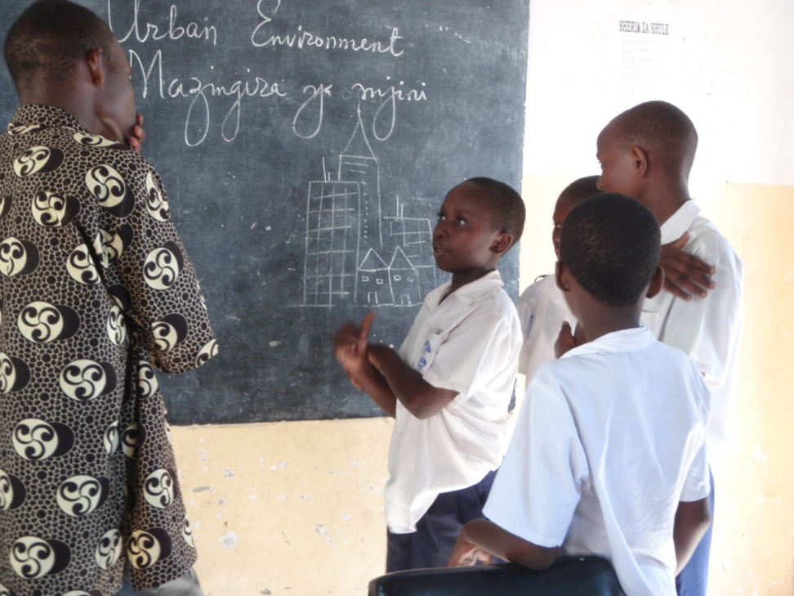
My research has illustrated that young people, who participated in environmental education projects across three communities in Tanzania, were often more concerned with environmental problems than local adults. They had a detailed, theoretical understanding of environmental issues, for example, several young people were able to discuss the depletion of the ozone layer in detail (Smith 2013). NGO projects and state curricula were therefore somewhat successful in instilling concern for environmental issues in young people (Fig. 1).
Fig. 1: Young people were able to describe environmental issues in detail in the context of the school.
However, there was an apparent rift opening between the knowledges and ideas of young people and adults. Adult’s felt that knowledge learnt at school was too ‘theoretical’, suggesting that it had little ‘practical’ use value outside of school (Smith 2013). Adult concerns suggest a geographical displacement of young people’s environmental knowledges learnt at school, judged as too ‘theoretical’ to be useful in everyday practices outside of school.
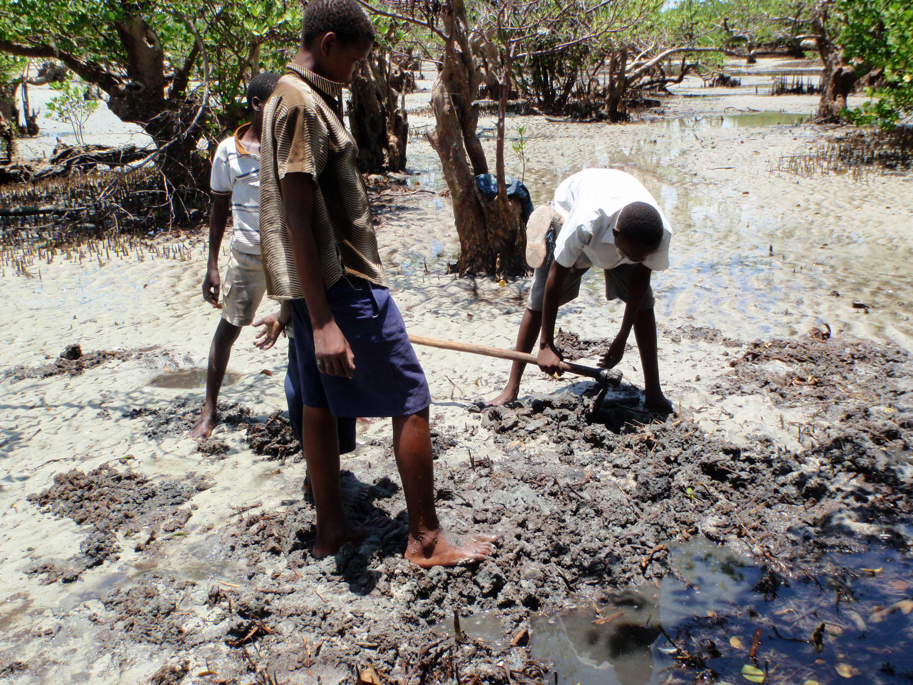
When asked about what young people would do with their knowledge, 60% of teachers interviewed made reference to young people as the ‘future’ of society (Smith 2012). 25% of local adults also variably referred to young people as “The source of the community in the future”, and that “In a generation they will be able to save the environment”. Through this discourse, adults cast young people as agents of the future, innocent of the destructive present. This seems contradictory to the fact that young people in Tanzania play an often crucial role in the livelihoods of families (Fig. 2). What it may expose is how young people are marginal from family decision-making, and may only be allocated agency to make decisions in the future. This restricts the agency of young people to a particular domain of time, a temporal displacement of their identities as environmental managers.
Fig. 2: Young people play a crucial role in livelihood reproduction. Here young men dig for worms to be used as fishing bait.
The geographical and temporal displacement of young people’s knowledge and agency is not unique to Tanzania. Other research has illustrated how young people’s identities are constructed around displacement of their identity to the future, not only by adults but by young people themselves, in diverse contexts as Uganda (Van Blerk 2005), India (Dyson 2008; Jeffery 2010) and the UK (Sutton 2009).
This geographical and temporal displacement raises questions about the value of current education projects to dealing with environmental change and food security locally. What appears lacking is a mechanism to allow young Tanzanian’s to use this knowledge in their everyday lives. The temporal displacement of young people’s agency is common across cultural contexts, yet without being able to exercise their knowledge and agency in the present, it becomes difficult to discern how they might employ this knowledge in the future. This parallels concerns expressed by Punch (2004), that formal education in the global South is unlikely to increase young people’s livelihood alternatives within their local context. Whilst young people may learn about environmental change in school, this is likely to have little effect on how they practice agriculture, pastoralism, or fishing in the present and the future. Temporal displacement of young people’s agency may act to prevent them from taking action in the present if they can only ever be envisaged as having the power to act ‘in the future’.

References:
Briggs, J., Sharp, J., Yacoub, H., Hamed, N. and Roe, A. (2007) The nature of indigenous environmental knowledge production: evidence from Bedouin communities in Southern Egypt, Journal of International Development, 19, 239-251.
Dyson, J. (2008) Harvesting identities: youth, work, and gender in the Indian Himalayas, Annals of the Association of American Geographers, 98 (1), 160-179.
Hoza, J.T. (2009) Capacity building for environmental education and ESD: Status and opportunities in Tanzania, Paper presented to the National Environmental Education Forum, 18th-19th June, Morogoro, Tanzania.
Jeffery, C. (2010) Timepass: youth, class, and time among unemployed young men in India, American Ethnologist, 37 (30), 465-481.
Punch, S. (2004) The impact of primary education on school-to-work transitions for young people in rural Bolivia. Youth and Society, 36 (2), 163–182.
Mbuta, M. C. (2009) The future of environmental education for sustainable development in Tanzania, Paper presented to the National Environmental Education Forum, 18th-19th June, Morogoro, Tanzania.
Moyo, H. Z. B. (2009) Indigenous knowledge-based farming practices: A setting for the contestation of modernity, development, and progress. Scottish Geographical Journal, 125 (3-4), 353-360.
National Bureau of Statistics (NBS) Tanzania (2006) Analytical Report: Tanzania Census 2002, National Bureau of Statistics, Ministry of Planning, Economy and Empowerment, Dar es Salaam, Tanzania, August 2006.
National Environmental Management Council (NEMC), United Republic of Tanzania (2004), National Environmental Education and Communication Strategy 2005-2009.
Smith, T. A. (2012) At the crux of development? Local knowledge, participation, empowerment and environmental education in Tanzania, Unpublished PhD thesis, The University of Glasgow.
Smith, T. A. (2013) The dominant/marginal lives of young Tanzanians: spaces of knowing at the intersection of Children’s Geographies and Development Geographies, Geoforum, 48, 10-23.
Sharp, J., Briggs, J., Yacoub, H. And Hamed, N. (2003) Doing gender and development: understanding empowerment and local relations, Transactions of the Institute of British Geographers, NS 28, 281-295.
Sutton, L. (2009) ‘They’d only call you a scally if you are poor’: the impact of socio-economic status on Chilren’s identities, Children’s Geographies, 7 (3), 277-290.
Van Blerk, L. (2005) Negotiating spatial identities: mobile perspectives on street life in Uganda, Children’s Geographies, 3 (1), 5-21.

Dr Thomas Aneurin Smith
Department of Geography,
The University of Sheffield,
Sheffield, S10 2TN,
United Kingdom
T.Smith@Sheffield.ac.uk
http://www.sheffield.ac.uk/geography/staff/smith_tom

