On 18 April 2012 more than 60 academics, students, teachers and representatives from Non Governmental Organisations (NGOs) attended the UK launch of the new edition of the internationally popular development education resource, 80:20 – Development in an unequal world. The launch, hosted by The Glasgow Centre for International Development (GCID) and The Centre for Research and Development in Adult and Lifelong Learning (CR&DALL) in conjunction with the Conforti Institute and Oxfam, were introduced to Colm Regan the book’s editor. Colm explained how the book, jointly published by 80:20 Educating and Acting for a Better World, Ireland and the University of South Africa Press is a development education resource designed and written by an international group of authors and educationalists to provide an introductory and accessible overview of development and human rights issues today. Now in its 6th edition it is extensively used by universities, schools, adult and youth organisations as well as by NGOs. Prof John Briggs highlighted Glasgow’s commitment to development issues and to the strong links between the University of South Africa and the University of Glasgow following the signing of a Memorandum of Understanding in 2010. Philippa Bonella, SCIAF’s head of Education and Communications spoke about how the book is used in classrooms in Scottish schools. Prof Mike Osborne emphasised the importance of a text that is used internationally to discuss the inequalities and injustices in the 21st century.
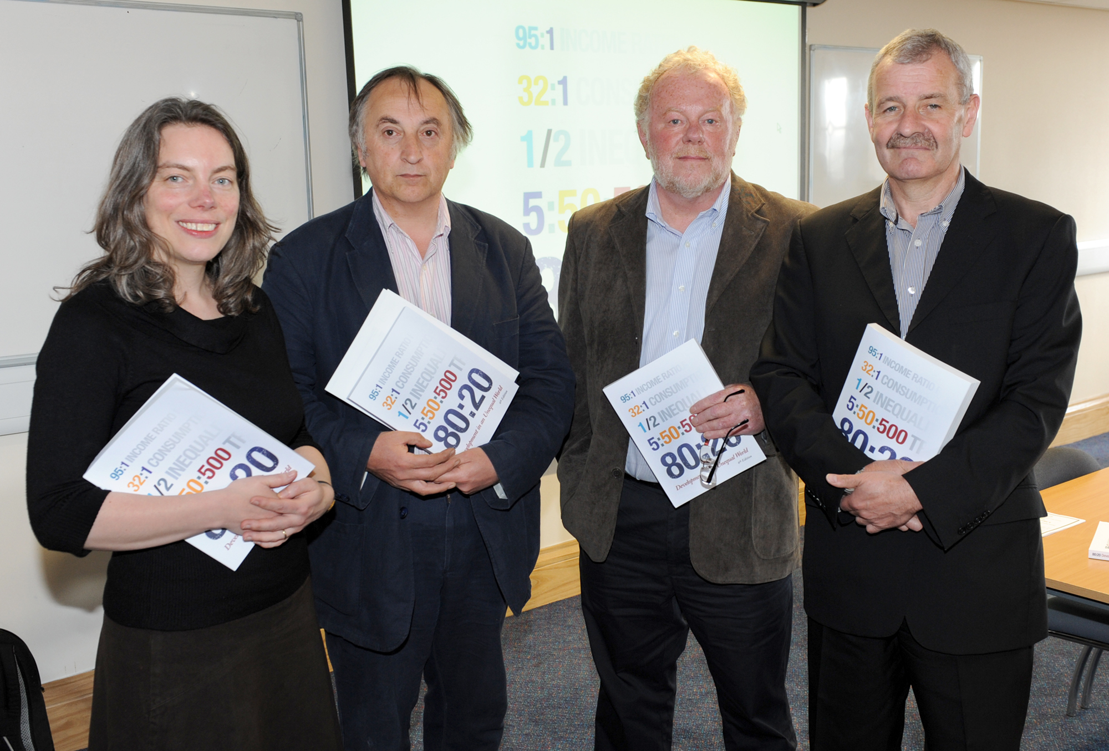
Philippa Bonella (SCIAF), Prof Mike Osborne (Director CR&DALL), Colm Regan (book’s editor), Prof John Briggs (Director GCID). (Picture courtesy of Paul McSherry).

